GREATER CAIRO METRO
LINE No.3 (Thawra Line)
TCMS-BC interface specification

Approved by | 26.Mar.2019 | K.K. SHIN | 
Reviewed by | 26.Mar.2019 | S.J. SEO | 
Written by | 26.Mar.2019 | H.KIM | 
 | Date | Name | Signature

Revision History
Issue | Page | Revision |  | Date
Issue | Page | Contents | Reference | Date
0 | All | First issue |  | 26.Mar.2019
1 | All | Modified by BC |  | 4.Apr.2019
2 | 12 | Battery Voltage was added | H.Kim | 7.Oct.2019
3 |  | SD Data was modified | J.W.LEE | 26.Nov.2019

Contents
1. INTRODUCTION 4
1.1. LIST OF ABBREVIATIONS 4
2. GENERAL 5
2.1. MVB Specification 5
2.2. MVB Connection 6
2.3. MVB Telegram 6
2.4. Train Formation of Cairo3 8
3. DATA EXCHANGE 10
3.1. TCMS → BC SDR (Status Data Request) 10
3.1.1. TCMS-BC-SDR 10
3.2. BC → TCMS SD(Status Data) 12
3.2.1. BC-TCMS-SD 12

INTRODUCTION
This document describes the interface specification between TCMS(Train Control and Monitoring System) and BC(Battery Charger) for GREATER CAIRO METRO LINE No.3 (Thawra Line) project.

LIST OF ABBREVIATIONS
TCN Train Control Network
MVB Multifunction Vehicle Bus
EMD Electrical Medium Distance
WTB Wire Train Bus
TCMS Train Control and Monitoring System
CCU Central Control Unit
VCU Vehicle Control Unit
IO-M remote IO Module
VVVF Variable Voltage Variable Frequency
DU Display Unit
RTD Remote Transmission Device
DCU Door Control Unit
ATP Automatic Train Protection
EBCU Electrical Brake Control Unit
VAC Ventilation Air conditioner Controller
TCU Traction Control Unit
APU Auxiliary Power Unit
EVR Event Recorder
HCR Header Car Relay
MF Major Fault
MCF Major Complementary Fault
HSCB High Speed Circuit Breaker
LB Line Bus Switch
PB Parking Brake
EB Emergency Brake
HB Holding Brake
FSB Full Service Brake
AUTO Automatic Mode
ADB All Door Bypass
ADC All Door Closed
AAU Automatic Announcement Unit
DCU Display Control Unit(for CCTV)
BC Battery Charger
HCR Head Control Relay
SDR Status Data Request
SD Status Data

GENERAL

MVB Specification
General specification of MVB is described as follow.
-. Redundancy : Line A, Line B
-. Master / Slave : TCMS is only Master.
The subsystem needs not to act as bus administrator.
-. Media Support : EMD(Electrical Middle Distance) Communication Distance within 200m
<Table 1 Summary of the Multifunction Vehicle Bus by IEC 61375-1>
topology | bus(electrical)  star(optical)
Media | Electrical Short Distance  Electrical Middle Distance  Optical Glass Fibre | twisted wire pair, biased RS-485  shielded twisted wire pair, transformer coupled  200/240 µm fibres and star coupler
Length | Electrical Short Distance  Electrical Middle Distance  Optical Glass Fibre | 20 m, 32 devices per segment  200 m, 32 devices per segment  2000 m
Physical Redundancy | duplicated physical medium(synchronous send)
Signalling | Manchester II, 9-bit frame Start Delimiter
Signalling rate | 1.5 Mbit/s
Address space | 12-bit Device Address  (0…255 reserved for devices with Message Data capability)  12-bit Logical Address for Process Data  (each 16…256 bits)
Physical Addressing | single cast and broadcast
Frame size  (useful data) | 16, 32, 64, 128, 256 bits
Integrity | CRC-8 per 64bits + Manchester encoding, different frame Start Delimiter for Master Frame and Slave Frame against synchronization slip, reception time window supervision
Medium Allocation | by one centralized Master(Hyundai-Rotem’s CCU & VCU)
Traffic | periodic(mainly for Process Data)  sporadic(mainly for Message Data)  supervisory(for Supervisory Data)
Mastership Transfer | mastership transfer by token passing  serveral Bus Administrators can become Master in turn
Mastership Redundancy  (Option) | redundant Bus Administrators serve as back-up
Link Layer Service | Link Process Data Interface  Link Message Data Interface  Link Supervision Interface |  | broadcast of source addressed data  datagrams  Link Layer Management

MVB Connection
Where interchangeability is required, Subsystems connected by MVB shall be attached to the cable as follow:
<Table 2 Pin assignment for the EMD Connector>
1 | A.Data_P positive wire of Line A | 6 | A.Term_P, Positive pole of Terminator Line A
2 | A.Data_N negative wire of Line A | 7 | A.Term_N, Negative pole of Terminator Line A
3 | Not Used | 8 | B.Term_P, Positive pole of Terminator Line B
4 | B.Data_P positive wire of Line B | 9 | B.Term_N, Negative pole of Terminator Line B
5 | B.Data_N negative wire of Line B
Note 1 It is recommend to arrange the two connectors side by side on a device, Connector 1 on the left and Connector 2 on the right, to thread the wiring neatly.
Note 2 It may be necessary to ensure that the connector case is isolated from the device case if connection of the device cases is not advisable, for instance when large stray currents are expected.
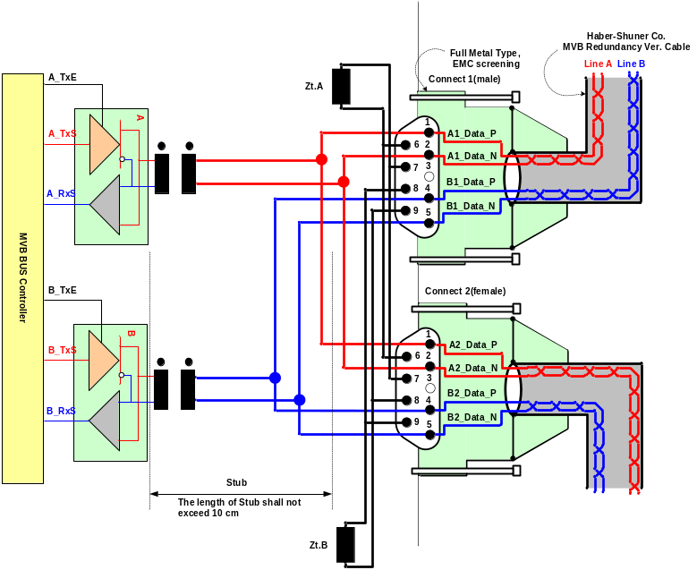
Figure 1 Double line EMD connector arrangement

MVB Telegram
There are 16 telegrams types on the MVB, which are distinguished by the F-code in Master Frame, as shown in Table 3.
Table 3 F-code of the MVB(Master Frame Type)

F-Code | Telegram Type
0 | Process Data Request with 16 bits
1 | Process Data Request with 32 bits
2 | Process Data Request with 64 bits
3 | Process Data Request with 128 bits
4 | Process Data Request with 256 bits
5 | (reserved)
6 | (reserved)
7 | (reserved)
8 | Mastership Transfer Request
9 | General Event Request
10 | (reserved)
11 | (reserved)
12 | Message Data Request
13 | Group Event Request
14 | Single Event Request
15 | Device Status Request
The basic data type for MVB network between TCMS and sub-system is WORD. Physical address is not used.
The byte ordering is the Big-Endian(Motorola) but, all data is read like word. So, the subsystem side must change like example.
The byte order and bit order for a data are as follows.
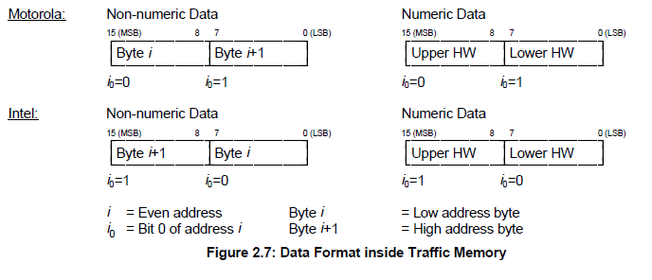
- MVB supervision :
The CCU is indicating the MVB state by the MVB watchdog counter that increases when the application is executed.
The counter from the MVB device is generated as soon as the application software is ready. If no MVB connection is established, i.e.
The MVB watchdog counter can not be received or an internal fault in the MVB device occurs, the signals, besides the watchdog counter, shall be had default value.
<Bit Ordering>
Data structures shall be numbered from left to right and from top to bottom, in the order of reading an English text. The first item on the top and to the left has offset zero.
WORD | Data Contents |  |  |  |  |  |  |  | Remark
WORD | Bit Mask |  |  |  |  |  |  |  | Remark
WORD | 15 | 14 | 13 | 12 | 11 | 10 | 9 | 8
WORD | 7 | 6 | 5 | 4 | 3 | 2 | 1 | 0
0 | 0 | 1 | 2 | 3 | 4 | 5 | 6 | 7
0 | 8 | 9 | 10 | 11 | 12 | 13 | 14 | 15
1 | 16 | 17 | 18 | 19 | 20 | 21 | 22 | 23
1 | 24 | 25 | 26 | 27 | 28 | 29 | 30 | 31
2 | 32 | 33 | 34 | 35 | 36 | 37 | 38 | 39
2 | 40 | 41 | 42 | 43 | 44 | 45 | 46 | 47
3 | 48 | 49 | 50 | 51 | 52 | 53 | 54 | 55
3 | 56 | 57 | 58 | 59 | 60 | 61 | 62 | 63
4 | 64 | 65 | 66 | 67 | 68 | 69 | 70 | 71
4 | 72 | 73 | 74 | 75 | 76 | 77 | 78 | 79
5 | 80 | 81 | 82 | 83 | 84 | 85 | 86 | 87
5 | 88 | 89 | 90 | 91 | 92 | 93 | 94 | 95
6 | 96 | 97 | 98 | 99 | 100 | 101 | 102 | 103
6 | 104 | 105 | 106 | 107 | 108 | 109 | 110 | 111
7 | 112 | 113 | 114 | 115 | 116 | 117 | 118 | 119
7 | 120 | 121 | 122 | 123 | 124 | 125 | 126 | 127
8 | 128 | 129 | 130 | 131 | 132 | 133 | 134 | 135
8 | 136 | 137 | 138 | 139 | 140 | 141 | 142 | 143
9 | 144 | 145 | 146 | 147 | 148 | 149 | 150 | 151
9 | 152 | 153 | 154 | 155 | 156 | 157 | 158 | 159
10 | 160 | 161 | 162 | 163 | 164 | 165 | 166 | 167
10 | 168 | 169 | 170 | 171 | 172 | 173 | 174 | 175
11 | 176 | 177 | 178 | 179 | 180 | 181 | 182 | 183
11 | 184 | 185 | 186 | 187 | 188 | 189 | 190 | 191
12 | 192 | 193 | 194 | 195 | 196 | 197 | 198 | 199
12 | 200 | 201 | 202 | 203 | 204 | 205 | 206 | 207
13 | 208 | 209 | 210 | 211 | 212 | 213 | 214 | 215
13 | 216 | 217 | 218 | 219 | 220 | 221 | 222 | 223
14 | 224 | 225 | 226 | 227 | 228 | 229 | 230 | 231
14 | 232 | 233 | 234 | 235 | 236 | 237 | 238 | 239
15 | 240 | 241 | 242 | 243 | 244 | 245 | 246 | 247
15 | 248 | 249 | 250 | 251 | 252 | 253 | 254 | 255

Train Formation of Cairo3
The train formation consists of 8 cars and can be seen in following figure. The detail arrangement is DTC-MC1-MC2-MCI-MCI-MC2-MC1-DTC. The two CCUs(Central Control Unit) are installed in both DTC, two VCUs are installed in MCI and two IO-Ms are installed in MC. CCU and VCU(Vehicle Control Unit) is connected to subsystem via MVB(Multifunction Vehicle Bus), WTB(Wire Train Bus) is used by the data communication interface between CCU and VCU.

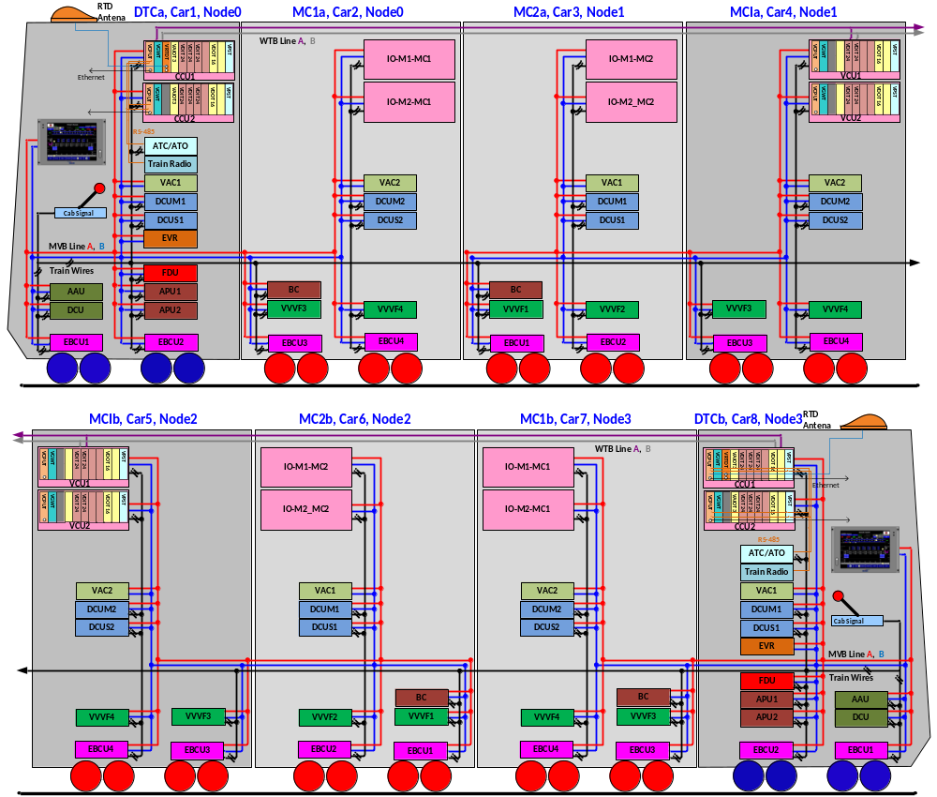

Figure 2 Configuration

DATA EXCHANGE

TCMS → BC SDR (Status Data Request)
Telegram name | Source | Sink | Port address | Fcode | Task | Remark
TCMS-BC-SDR | TCMS | BC ALL | 0x98 | 4

TCMS-BC-SDR
WORD | Data Contents |  |  |  |  |  |  |  | Remark
WORD | Bit Mask |  |  |  |  |  |  |  | Remark
WORD | 15 | 14 | 13 | 12 | 11 | 10 | 9 | 8
WORD | 7 | 6 | 5 | 4 | 3 | 2 | 1 | 0
0 | WatchDogCounterTCMS
1 | DateTimeYear
1 | DateTimeMonth
2 | DateTimeDay
2 | DateTimeHour
3 | DateTimeMinute
3 | DateTimeSec
4 | DateTimeValid |  |  |  | MVB_Node3(car7/8) | MVB_Node2(car5/6) | MVB_Node1(car3/4) | MVB_Node0(car1/2)
5
6
7
8
9
10
11
12
13
14
15

Bit  Offset | Data  Size | Data  Type | Data Name | Contents | Remarks
0 | 16 | UNSIGNED16 | WatchDogCounterTCMS | TCMS watchdog counter(0~65535)
16 | 8 | UNSIGNED8 | DateTimeYear | Year (00 – 99), | BCD
24 | 8 | UNSIGNED8 | DateTimeMonth | Month (1 – 12) | BCD
32 | 8 | UNSIGNED8 | DateTimeDay | Day (1 – 31) | BCD
40 | 8 | UNSIGNED8 | DateTimeHour | Hour (0 -23) | BCD
48 | 8 | UNSIGNED8 | DateTimeMinute | Minute (0 – 59) | BCD
56 | 8 | UNSIGNED8 | DateTimeSec | Second (0 – 59) | BCD
64 | 1 | BOOL | DateTimeValid | 0/1, 1 = Date & Time Validation
65 | 1 | BOOL
66 | 1 | BOOL
67 | 1 | BOOL
68 | 1 | BOOL | MVB_Node3(car7/8) | MVB NODE3 position(Refer to Fig2)
69 | 1 | BOOL | MVB_Node2(car5/6) | MVB NODE2 position(Refer to Fig2)
70 | 1 | BOOL | MVB_Node1(car3/4) | MVB NODE1 position(Refer to Fig2)
71 | 1 | BOOL | MVB_Node0(car1/2) | MVB NODE0 position(Refer to Fig2)

BC → TCMS SD(Status Data)
Telegram name | Source | Sink | Port address | Fcode | Task | Remark
BC-TCMS-SD | BC | TCMS | 0x9C | 4 | T(≤256ms)

BC-TCMS-SD
WORD | Data Contents |  |  |  |  |  |  |  | Remark
WORD | Bit Mask |  |  |  |  |  |  |  | Remark
WORD | 15 | 14 | 13 | 12 | 11 | 10 | 9 | 8
WORD | 7 | 6 | 5 | 4 | 3 | 2 | 1 | 0
0 | BC_WatchdogCounter(0~65535)  BC_WatchdogCounter (0 ~ 65535, 0000 – FFFFH, 1/bit)
1 | Spare
1 | Spare
2 | Spare  Battery Voltage (0 ~ 250V, 00 - FAH, 1V/bit)
2 | Spare
3 | Battery Charger Input Voltage (0 ~500V, 00 – FAH, 2V/bit)  Battery Charger Input Voltage (0 ~ 1000V, 00 - FAH, 4V/bit)
3 | Battery Charger Input Current (0 ~250A, 00 – FAH, 1A/bit)  Battery Charger Input Filter Capacitor Current (0 ~250A, 00 - FAH, 1A/bit)
4 | Battery Charger Input Filter Capacitor Voltage (0 ~1000V, 00 - FAH, 4V/bit)
4 | Battery Charger Output Voltage (0 ~ 250V, 00 - FAH, 1V/bit)
5 | Battery Charger Output Current (0 ~ 500A, 00 - FAH, 2A/bit)
5 | Battery Charger Charging Current (0 ~ 250A, 00 – FAH, 1A/bit)  Battery Charger Charging Current (-250 ~ 250A, 00 - FAH, 2A/bit)
6 | Battery Temperature (-20℃ ~ +110℃, 00 – 82H, 1℃/bit)  Battery Temperature (-60 ~ +190℃, 00 - FAH, 1℃/bit)
6 | Spare
7 | WHM (0000h to FFFFh, 6553.5 kWh, )  WHM (0 ~ 6553.5 kWh, 0000 - FFFFH, 0.1kWh/bit)
8 | Spare | START  on | BCCHKa | BCLKa | BCOKa | RESET | Spare | Spare
8 | BCPWM1  BCPWM | BCPWM2  Spare | BCPWM3  Spare | Spare | Spare | Spare | Spare | Spare  MODE
9 | BCGDF1 | BCGDF2 | BCGDF3  Spare | Spare | Spare | Spare | Spare | Spare
9 | BCINOVF | BCDCOVF | BCDCUVF | BCOVOVF | Spare | Spare | Spare | Spare
10 | BCINOCF  Spare | BCDCOCF | BCOCOCF | BCBATOCF | BCCPSF | Spare | Spare | Spare
10 | MJF | BCCHKF | BCLKF | BCOKF | BCTHF | Spare | Spare | Spare
11 | Ver(0~250, 00 – FAH, 0.1/bit)  Ver (0.0 ~ 9.9, 00 – 63H, 0.1/bit)
11 | Spare
12 | Spare | Spare | Spare | Spare | Spare | Spare | Spare | Spare
12 | Spare | Spare | Spare | Spare | Spare | Spare | Spare | Spare
13 | Spare | Spare | Spare | Spare | Spare | Spare | Spare | Spare
13 | Spare | Spare | Spare | Spare | Spare | Spare | Spare | Spare
14 | Spare | Spare | Spare | Spare | Spare | Spare | Spare | Spare
14 | Spare | Spare | Spare | Spare | Spare | Spare | Spare | Spare
15 | Spare | Spare | Spare | Spare | Spare | Spare | Spare | Spare
15 | Spare | Spare | Spare | Spare | Spare | Spare | Spare | Spare

Bit  Offset | Data  Size | Data  Type | Data Name | Contents | Remarks
0 | 16 | UNSIGNED16 | BC_WatchdogCounter | -. Range: 0 to 65535 (00H to FFH)  -. BC increments this bit every transmission cycle. TCMS ignores the information of SD if this counter is not incremented for more than "1000ms". | Word00
16 | 8 | UNSIGNED8 | Spare | -. Spare | Word01
24 | 8 | UNSIGNED8 | Spare | -. Spare | Word01
32 | 8 | UNSIGNED8 | Spare | -. Spare | Word02
40 | 8 | UNSIGNED8 | Spare  Battery Voltage | -. Spare  -. Range: 0 to 250V (00H to FAH, 1V/bit) | Word02
48 | 8 | UNSIGNED8 | Battery Charger Input Current  Battery Charger Input Filter Capacitor Current | -. Range: 0 to 250A (00H to FAH, 1A/bit) | Word03
56 | 8 | UNSIGNED8 | Battery Charger Input Voltage | -. Range: 0 to 500V (00h to Fah, 2V/bit)  -. Range: 0 to 1000V (00H to FAH, 4V/bit) | Word03
64 | 8 | UNSIGNED8 | Battery Charger Output Voltage | -. Range: 0 to 250V (00H to FAH, 1V/bit) | Word04
72 | 8 | UNSIGNED8 | Battery Charger Input filter Capacitor Voltage | -. Range: 0 to 1000V (00H to FAH, 4V/bit) | Word04
80 | 8 | UNSIGNED8 | Battery Charger Output Current  Battery Charger Charging Current | -. Range: 0 to 500A (00h to Fah, 2A/bit)  -. Range: -250 to 250A (00H to FAH, 2A/bit) | Word05
88 | 8 | UNSIGNED8 | Battery Charger Output Voltage  Battery Charger Output Current | -. Range: -200 to 250V (00h to Fah, 1V/bit)  -. Range: 0 to 500A (00H to FAH, 2A/bit) | Word05
96 | 8 | UNSIGNED8 | Spare | -. Spare | Word06
104 | 8 | UNSIGNED8 | Battery Temperature | -. Range: -20℃ to +110℃ (00h to 82h, 1℃/bit)  -. Range: -40 to +125℃ (00H to A6H, 1℃/bit) | Word06
112 | 16 | UNSIGNED16 | Watt-hour meter for power consumption | -. Range: 0 to 6553.5kWh (0000H to FFFFH)  -. When this value exceeds 6553.5kWh (FFFFH), it will be reset to 0kWh (0000H).  -. This value will be reset to 0kWh when BC is powered off. | Word07
128 | 1 | BOOL | Spare  MODE | -. Spare  -.HIGH(1): Normal Mode status | Word08
129 | 1 | BOOL | Spare | -. Spare | Word08
130 | 1 | BOOL | Spare | -. Spare | Word08
131 | 1 | BOOL | Spare | -. Spare | Word08
132 | 1 | BOOL | Spare | -. Spare | Word08
133 | 1 | BOOL | BCPWM3  Spare | -. HIGH(1) : Battery Charger IGBT Gate3 ON  -. Spare | Word08
134 | 1 | BOOL | BCPWM2  Spare | -. HIGH(1) : Battery Charger IGBT Gate2 ON  -. Spare | Word08
135 | 1 | BOOL | BCPWM1  BCPWM | -. HIGH(1) : Battery Charger IGBT Gate1 ON  -. HIGH(1) : Battery Charger IGBT Gate ON | Word08
136 | 1 | BOOL | Spare | -. Spare | Word08
137 | 1 | BOOL | Spare | -. Spare | Word08
138 | 1 | BOOL | RESET | -. HIGH(1) : RESET | Word08
139 | 1 | BOOL | BCOKa | -. HIGH(1) : BCOK(BC Output Contactor) Exciting Coil ON | Word08
140 | 1 | BOOL | BCLKa | -. HIGH(1) : LK(Line Contactor) Exciting Coil ON | Word08
141 | 1 | BOOL | BCCHKa | -. HIGH(1) : CHK(Charging Contactor) Exciting Coil ON | Word08
142 | 1 | BOOL | START ON | -. HIGH(1) : Start on status. | Word08
143 | 1 | BOOL | Spare | -. Spare | Word08
144 | 1 | BOOL | Spare | -. Spare | Word09
145 | 1 | BOOL | Spare | -. Spare | Word09
146 | 1 | BOOL | Spare | -. Spare | Word09
147 | 1 | BOOL | Spare | -. Spare | Word09
148 | 1 | BOOL | BCOVOVF | -.HIGH(1) : Output over voltage detection | Word09
149 | 1 | BOOL | BCDCUVF | -.HIGH(1) : Input Filter Capacitor under voltage detection | Word09
150 | 1 | BOOL | BCDCOVF | -.HIGH(1) : Input Filter Capacitor over voltage detection | Word09
151 | 1 | BOOL | BCINOVF | -.HIGH(1) : Input over voltage detection | Word09
152 | 1 | BOOL | Spare | -. Spare | Word09
153 | 1 | BOOL | Spare | -. Spare | Word09
154 | 1 | BOOL | Spare | -. Spare | Word09
155 | 1 | BOOL | Spare | -. Spare | Word09
156 | 1 | BOOL | Spare | -. Spare | Word09
157 | 1 | BOOL | BCGDF3  Spare | -.HIGH(1) : Gate Driver Failure3, Battery Charger IGBT 3  -. Spare | Word09
158 | 1 | BOOL | BCGDF2 | -.HIGH(1) : Gate Driver Failure2, Battery Charger IGBT 2 | Word09
159 | 1 | BOOL | BCGDF1 | -.HIGH(1) : Gate Driver Failure1, Battery Charger IGBT 1 | Word09
160 | 1 | BOOL | Spare | -. Spare | Word10
161 | 1 | BOOL | Spare | -. Spare | Word10
162 | 1 | BOOL | Spare | -. Spare | Word10
163 | 1 | BOOL | BCTHF | -.HIGH(1) : Stack over temperature detection | Word10
164 | 1 | BOOL | BCOKF | -.HIGH(1) : BC Output Contactor fault detection | Word10
165 | 1 | BOOL | BCLKF | -.HIGH(1) : Line Contactor fault detection | Word10
166 | 1 | BOOL | BCCHKF | -.HIGH(1) : Charging Contactor fault detection | Word10
167 | 1 | BOOL | MJF | -.HIGH(1) : Major Failure happened | Word10
168 | 1 | BOOL | Spare | -. Spare | Word10
169 | 1 | BOOL | Spare | -. Spare | Word10
170 | 1 | BOOL | Spare | -. Spare | Word10
171 | 1 | BOOL | BCCPSF | -.HIGH(1) : Control Power Supply failure detection | Word10
172 | 1 | BOOL | BCBATOCF | -.HIGH(1) : Battery Charging current over current detection | Word10
173 | 1 | BOOL | BCOCOCF | -.HIGH(1) : Battery Charger output current over current detection | Word10
174 | 1 | BOOL | BCDCOCF | -.HIGH(1) : Battery charger DC input current over current detection | Word10
175 | 1 | BOOL | BCINOCF  Spare | -.HIGH(1) : Battery charger AC input current over current detection  -. Spare | Word10
176 | 8 | UNSIGNED8 | Spare | -. Spare | Word11
184 | 8 | UNSIGNED8 | Ver | -. Version  -. 0 ~ 250, 00 – FAH, 0.1/bit  -. 0.0 ~ 9.9, 00H to 63H, 0.1/bit  -. Ex) 00H = Ver 0.0  -. Ex) 0AH = Ver 1.0 | Word11
192 | 8 | BOOL | Spare | -. Spare | Word12
200 | 8 | BOOL | Spare | -. Spare | Word12
208 | 8 | BOOL | Spare | -. Spare | Word13
216 | 8 | BOOL | Spare | -. Spare | Word13
224 | 8 | BOOL | Spare | -. Spare | Word14
232 | 8 | BOOL | Spare | -. Spare | Word14
240 | 8 | BOOL | Spare | -. Spare | Word15
248 | 8 | BOOL | Spare | -. Spare | Word15

